LAB PROGRAM 5

**QUESTION: Develop a Java program to create a class Bank that maintains two kinds of account for its customers, one called savings account and the other current account. The savings account provides compound interest and withdrawal facilities but no cheque book facility. The current account provides cheque book facility but no interest. Current account holders should also maintain a minimum balance and if the balance falls below this level, a service charge is imposed. Create a class Account that stores customer name, account number and type of account. From this derive the classes Cur-acct and Sav-acct to make them more specific to their requirements. Include the necessary methods in order to achieve the following tasks: a) Accept deposit from customer and update the balance. b) Display the balance. c) Compute and deposit interest d) Permit withdrawal and update the balance Check for the minimum balance, impose penalty if necessary and update the balance**

**CODE:**

**import java.util.Scanner;**

**class Account**

**{**

**String name;**

**int type;**

**long accno;**

**double balance;**

**void setA()**

**{**

**Scanner s=new Scanner(System.in);**

**System.out.print("Enter customer name: ");**

**name=s.nextLine();**

**System.out.print("Enter account number: ");**

**accno=s.nextLong();**

**System.out.print("Enter bank balance: ");**

**balance=s.nextDouble();**

**}**

**void display()**

**{**

**System.out.println("Customer name is: "+name);**

**if(type==1) {**

**System.out.println("Customer account type is: Savings");**

**}**

**else {**

**System.out.println("Customer account type is: Current");**

**}**

**System.out.println("Customer account number is: "+accno);**

**System.out.println("Current balance is: "+balance);**

**}**

**void deposit()**

**{**

**System.out.print("Enter the amount to be deposited: ");**

**Scanner x=new Scanner(System.in);**

**double amt=x.nextDouble();**

**balance+=amt;**

**}**

**}**

**class Sav_acct extends Account**

**{**

**double interest;**

**Scanner s=new Scanner(System.in);**

**Sav_acct() {**

**type=1;**

**}**

**void cinterest()**

**{**

**int timey;**

**float irate;**

**System.out.println("Compound Interest details:");**

**System.out.println("Enter time in years: ");**

**timey=s.nextInt();**

**System.out.println("Enter rate of interest: ");**

**irate=s.nextFloat();**

**System.out.println("Interest will be compunded 5 times a year");**

**interest=balance*(Math.pow((1+irate/5),(5*timey)));**

**balance+=interest;**

**}**

**void withdraw()**

**{**

**System.out.println("Enter the amount to be withdrawn: ");**

**double amt=s.nextDouble();**

**if(balance>amt)**

**{balance-=amt;}**

**else**

**{System.out.println("Amount to be withdrawn greater than balance!!!");}**

**}**

**}**

**class Curr_acct extends Account**

**{**

**double check_amt;**

**Curr_acct() {**

**type=2;**

**}**

**void cheque()**

**{**

**System.out.print("Enter the cheque amount: ");**

**Scanner s=new Scanner(System.in);**

**check_amt = s.nextDouble();**

**if(check_amt>balance-5000)**

**{**

**System.out.println("Rs. 500 penalty imposed...Is it ok to proceed? Enter y for yes and n for no");**

**String option=s.next();**

**if(option.equals("y")) {balance=balance-check_amt-500;}**

**else {System.out.println("no check debited");}**

**}**

**else**

**{**

**System.out.println("Rupees "+check_amt+" debited"); balance-=check_amt;**

**}**

**}**

**void withdraw()**

**{**

**System.out.println("Enter the amount to be withdrawn: "); Scanner s=new Scanner(System.in);**

**double amt=s.nextDouble();**

**if(balance>amt)**

**{balance-=amt;}**

**else**

**{System.out.println("Amount to be withdrawn greater than balance!!!");}**

**}**

**}**

**class Bank {**

**public static void main(String ss[]) {**

**String op1,op2;**

**Scanner s=new Scanner(System.in);**

**System.out.println("1. Savings or 2. Current?");**

**int q;**

**q=s.nextInt();**

**if(q==1) {**

**Sav_acct s1 = new Sav_acct();**

**while(true) {**

**System.out.print("Enter the choice: \n1 .Set the values for savings acc\n2. display\n3. deposit\n4. Interest\n5. Withdraw\n6. exit\n");**

**op1=s.next();**

**switch(op1)**

**{**

**case "1":s1.setA();**

**break;**

**case "2":s1.display();**

**break;**

**case "3":s1.deposit();**

**break;**

**case "4":s1.cinterest();**

**break;**

**case "5":s1.withdraw();**

**break;**

**case "6":System.exit(0);**

**}**

**}**

**}**

**else if(q==2) {**

**Curr_acct c1 = new Curr_acct();**

**while(true) {**

**System.out.print("Enter the choice: \n1.Set the values for current account\n2. display\n3. deposit\n4. transferCheck\n5. Withdraw\n6. exit\n");**

**op2=s.next();**

**switch(op2)**

**{**

**case "1":c1.setA();**

**break;**

**case "2":c1.display();**

**break;**

**case "3":c1.deposit();**

**break;**

**case "4":c1.cheque();**

**break;**

**case "5":c1.withdraw();**

**break;**

**case "6":System.exit(0);**

**}**

**}**

**}**

**}**

**}**

# WRITTEN CODE

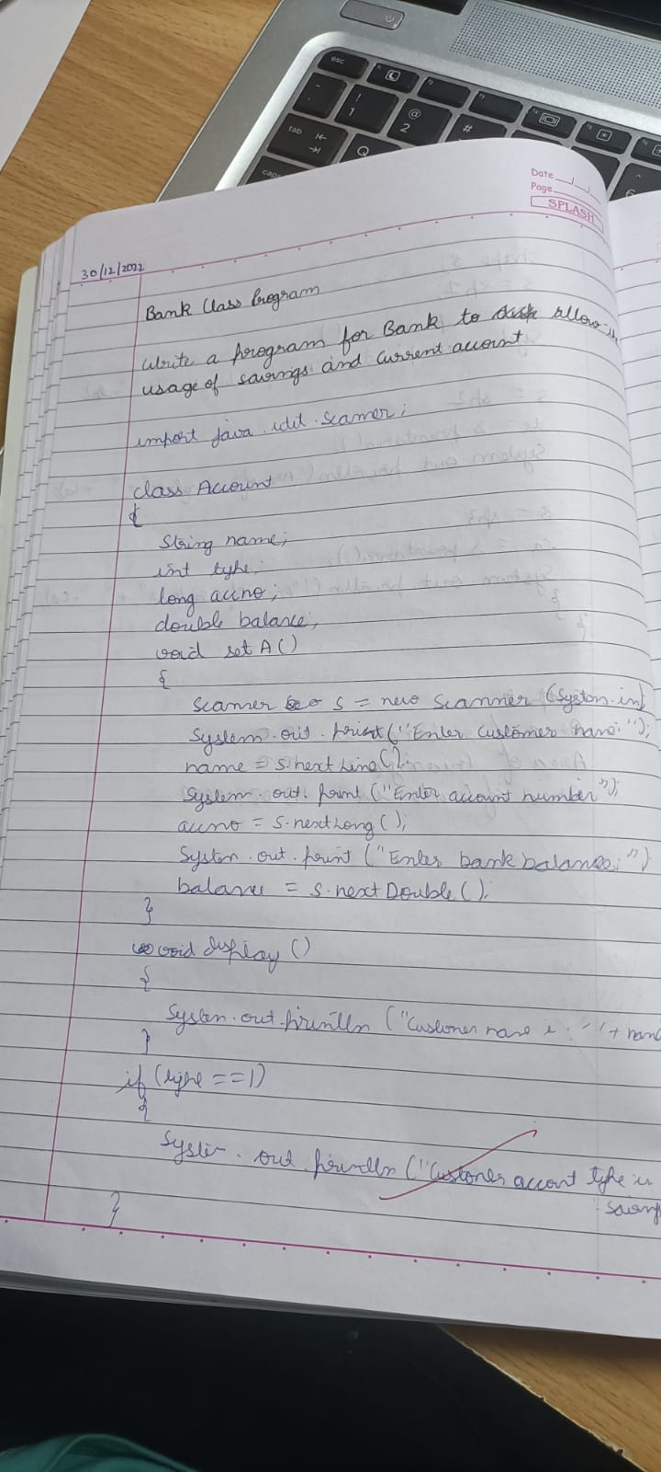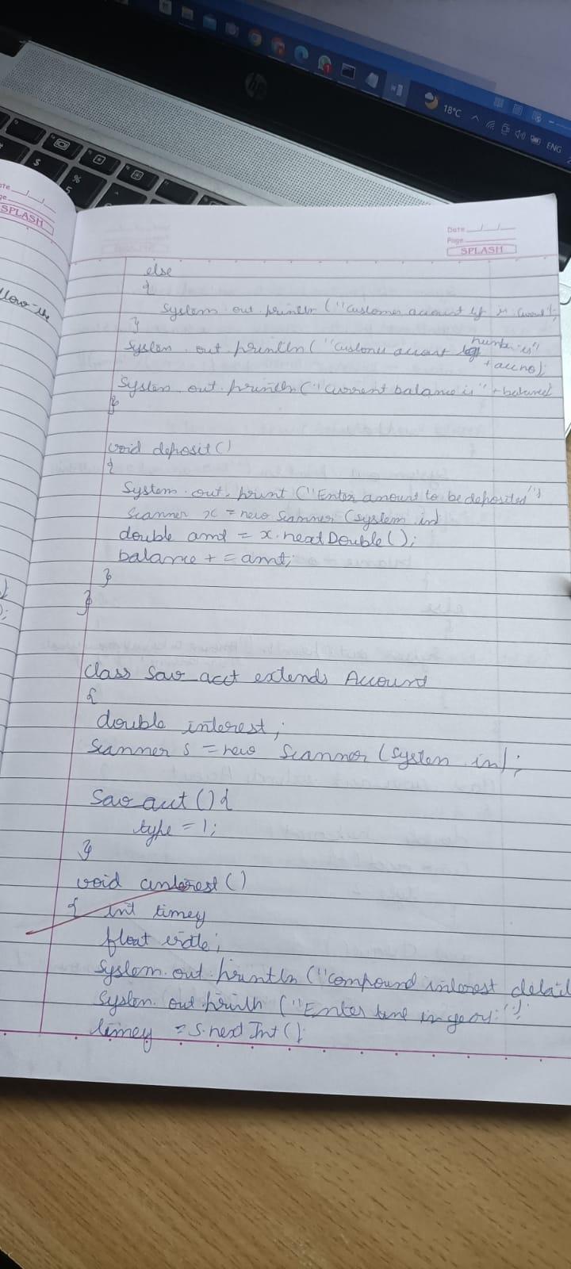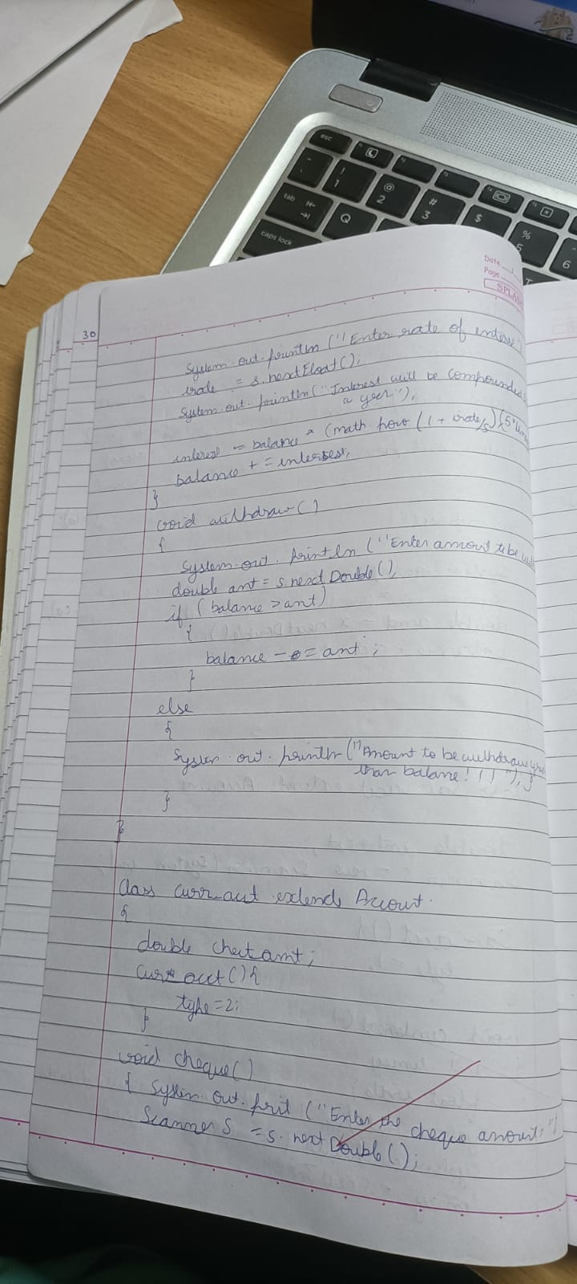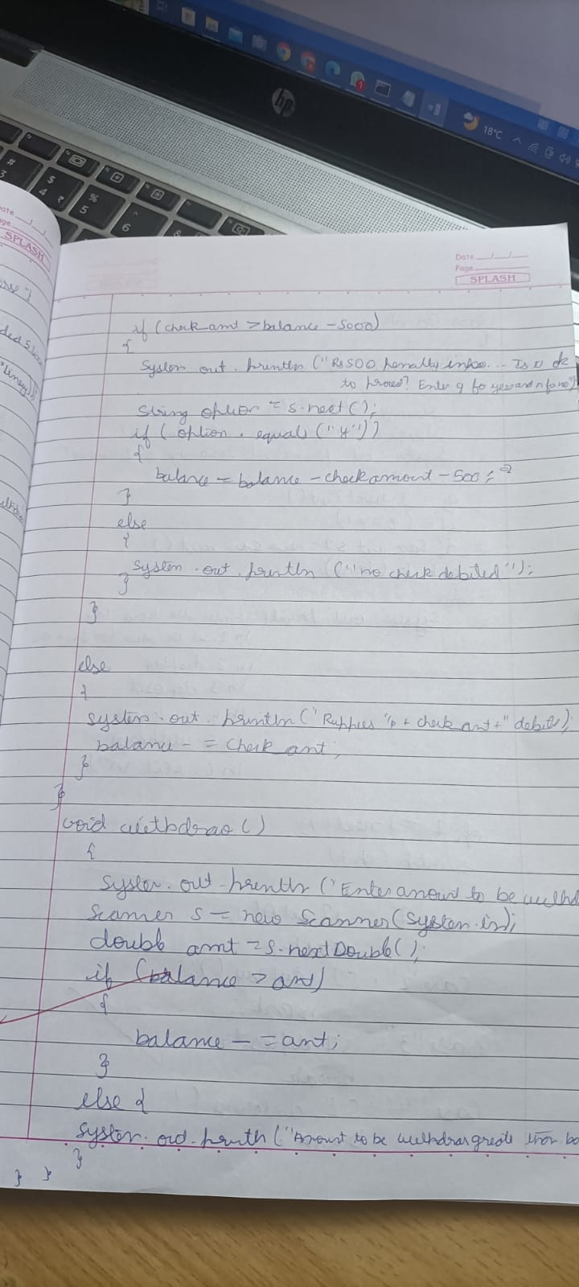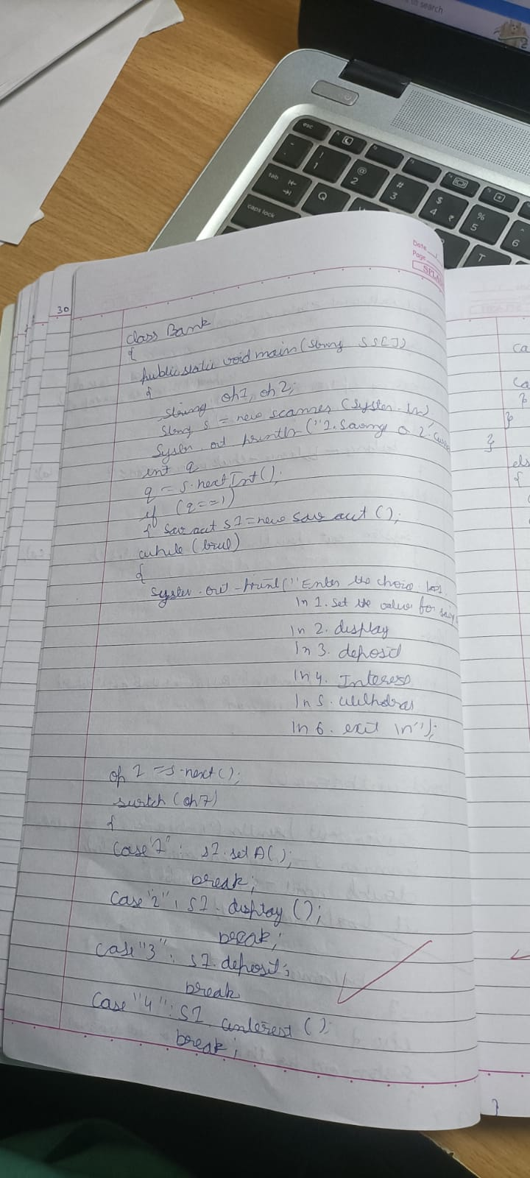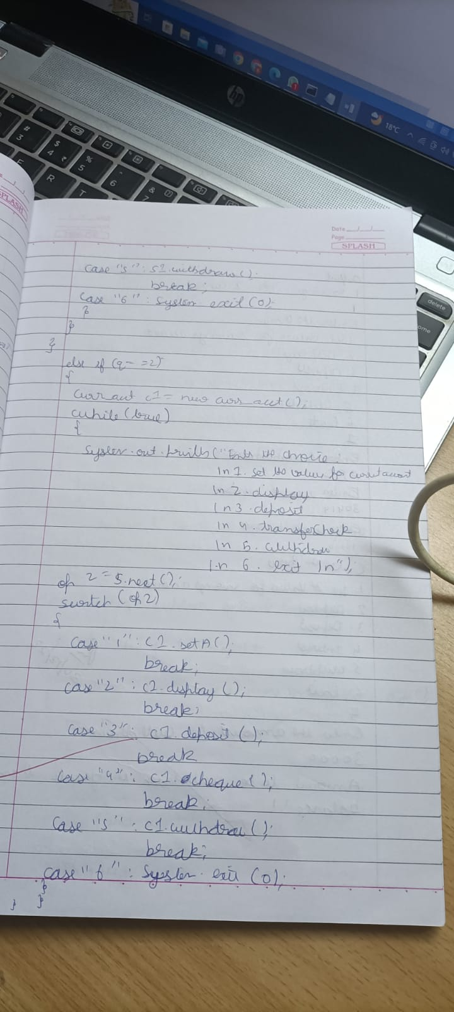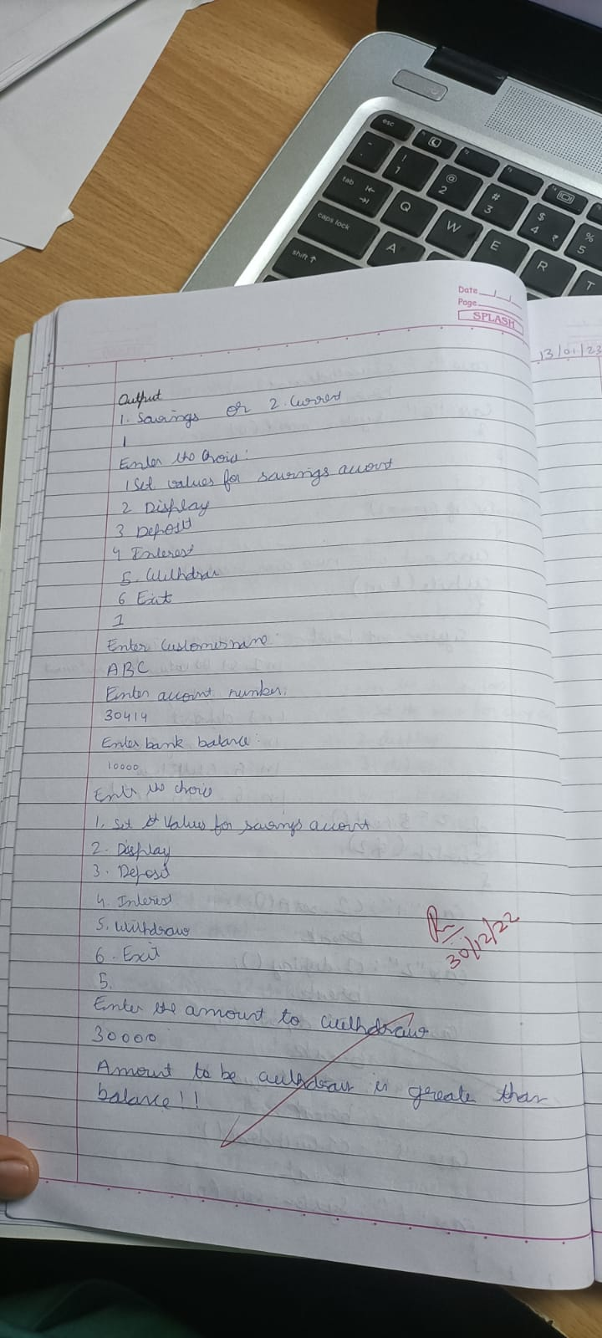

# OUTPUT

